A Parent’s Guide to supporting GCSE History students
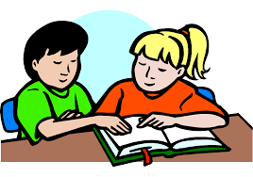

How can I help?
Talk to your child about their History lessons.
Ask to see their exercise book- check content, feedback, green pen, organisation and presentation.
Check Show My Homework regularly and ask if homework has been completed.
Ask how they have performed in any recent assessments.
Buy the revision guide.
Provide a quiet place for work.
Limit the use of technology/games.
Test your child’s subject knowledge.
Look at EDEXCEL exam board website.
Encourage your child to use BBC Bitesize.
Take them on a History trip, the Cold War exhibit at RAF Cosford is excellent.
Watch History documentaries together, such as BBC Rise of Nazis.
Watch History films together, for example Dunkirk.
Talk to your child about politics and use political terminology, do they understand the difference between left wing and right wing?
Talk to your chid about events that you remember such as the fall of the Berlin Wall/ Chernobyl/death of Princess Diana.
Talk to your chid about turning point events such as 9/11 and discuss their significance.
Discuss “fake news”, how do we know who is telling the truth, what is propaganda, watch Ian Hislop’s Fake News A True History?

qualifications.pearson.com/en/qualifications/edexcel-gcses/history-2016.html
www.bbc.co.uk/schools/gcsebitesize/history

