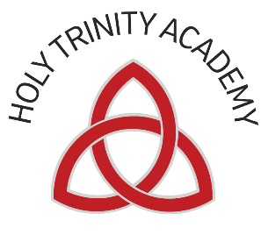

HOLY TRINITY ACADEMY

Person Specification Teacher

Essential Qualities
- Ability to teach outstanding lessons
- Qualified teacher status
- Experience of teaching students across the whole ability and age range
- Evidence of appropriate CPD related to developing teaching and learning
- Commitment to raising achievement through enabling all young people to achieve their potential
- Ability to analyse and interpret data, and use it to identify underachievement
- Commitment to work as a member of a team
- Patience, flexibility, approachability and a positive and energetic approach to work
- A creative and imaginative thinker who has the ability to identify innovative solutions to problems.
- Good organisational skills
- Empathy and understanding of the difficulties often faced by young people
- Ability to show initiative and work independently
- Understanding of the need to set boundaries for young people and enforce them
- Commitment to equality and social inclusion
- Ability to develop good relationships with all members of the school community
- Resilience under pressure
- Commitment to the pastoral care and welfare of students
- Commitment to and understanding of the professional development of self and colleagues
- A desire and ability to motivate and inspire young people
- A desire and ability to motivate and inspire colleagues
- Honours degree

Desirable Qualities
- Willingness to be involved in the wider life of the school

