Moving into KS3 English
Name: ________________________
Previous School:_________________
Instructions:
Work through the tasks and activities in the booklet.

Bring it into your English lessons at the start of next year!

There are some tasks that are more challenging than others.
Green Tasks – easiest level of challenge.
Red Tasks – Medium level of challenge (you must complete the green challenges too)
Black Tasks – High level of challenge (you must complete the green and red challenged too)

Choose the level of challenge that suits you and complete those tasks.

Good luck!

All things HTA!
F | P | E | R | E | D | U | X | S | M | N | L | Y | N | Z | Y | H | S | R | S
S | R | A | S | K | C | U | Y | R | P | N | M | O | F | E | A | O | E | M | T
Y | B | A | S | N | E | N | S | W | K | A | H | S | H | J | E | L | C | F | R
W | N | G | N | T | I | P | E | G | Q | T | T | A | I | C | I | Y | O | R | O
B | Y | O | M | C | O | K | D | I | A | C | O | C | N | G | Y | T | N | I | P
O | S | C | I | T | A | R | T | D | C | Z | M | E | I | P | R | R | D | E | S
O | U | H | T | T | B | I | A | A | K | S | I | O | R | S | O | I | A | N | L
K | W | S | T | B | A | E | S | L | W | C | U | O | H | B | T | N | R | D | O
C | V | N | M | A | R | C | Z | I | S | S | D | Q | R | U | S | I | Y | S | O
L | A | E | N | R | M | W | U | R | E | U | R | F | M | L | I | T | S | W | H
U | H | S | I | L | G | N | E | D | C | H | P | M | B | C | H | Y | C | S | C
B | G | M | E | W | O | T | U | E | E | A | O | P | X | X | N | A | H | Y | S
U | W | H | J | S | U | C | D | M | S | L | H | M | O | Q | U | C | O | H | R
J | S | W | N | P | A | E | A | S | D | A | A | Y | S | R | M | A | O | P | E
P | U | H | M | T | S | I | I | R | R | L | T | C | L | L | T | D | L | A | T
F | O | O | I | I | Q | S | T | N | E | M | H | C | I | R | N | E | Q | R | F
J | C | O | G | S | I | X | T | H | F | O | R | M | N | S | C | M | W | G | A
K | N | N | D | L | I | D | D | E | L | L | F | R | Y | S | Y | Y | X | O | B
S | N | O | I | T | I | T | E | P | M | O | C | E | S | U | O | H | V | E | V
B | U | S | I | N | E | S | S | S | T | U | D | I | E | S | F | H | P | G | E

There is one that can’t be found: What is it?
Afterschool sports, Business studies, English, Friends, History, Johnson, Mr Neal, Pastoral Support, PSHE, Science, Assisi, Clubs, Enrichment, Fry, Holy Trinity Academy, Liddell, Mrs Potts, Physical Education, Readathon, Secondary School, Book Club, Sixth Form, Religious Education, Product Design, Computer Science, Francais, Geography, House Competitions, Maths, Mrs Watkins.

Task: Describe your new school building

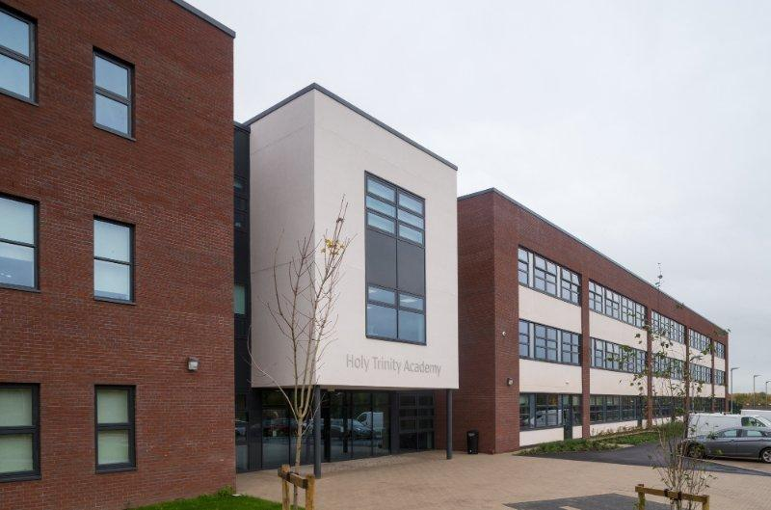
You can describe it however you would like to – remember those brilliant adjectives and similes, metaphors etc. that you can use. You could make it terrifying, happy, come alive… We’d like to see your creativity.
……………………………………………………………………………………………………………………………………………………………………………………………………………………………………………………………………………………………………………………………………………………………………………………………….............................................
………………………………………………………………………………………………………………………………………………………………………………………………………………………………………………………………………………………………………………………………………………………………………………………………............................................………………………………………………………………………………………………………………………………………………………………………………………………………………………………………………………………………………………………………………………………………………………………………………………………............................................………………………………………………………………………………………………………………………………………………………………………………………………………………………………………………………

Introduction to ‘Animal poetry’

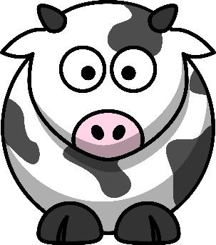
What is your favourite animal and why?
…………………………………………………………………………………………………………………………………………………………………………………………………………………………………………………………………………………………………………………………………………

If you could be any animal – what would you be and why? (Really think about it and justify your answer with at least three reasons).

…………………………………………………………………………………………………………………………………………………………………………………………………………………………………………………………………………………………………………………………………………
…………………………………………………………………………………………………………………………………………………………………………………………………………………………………………………………………………………………………………………………………………
…………………………………………………………………………………………………………………………………………………………………………………………………………………………………………………………………………………………………………………………………………

Draw an animal of your choice and then label him with amazing adjectives.

Task: Write a poem about ‘animals’ or as an animal and then decorate it.
These will be judged and could be part of an exciting competition in Year 7!

Read the following extract from a novel you could study in Year 7:

‘As I wrote down Mr. Browne’s September precept, I suddenly realised that I was going to like school. No matter what.

Via had warned me about lunch in middle school, so I guess I should have known it would be hard. I just hadn’t expected it to be this hard. Basically, all the kids from all the fifth-grade classes poured into the cafeteria at the same time, talking loudly and bumping into one another while they ran to different tables. One of the lunchtime teachers said something about no seat-saving allowed, but I didn’t know what she meant and maybe no one else did, either, because just about everybody was saving seats for their friends. I tried to sit down at one table, but the kid in the next chair said, “Oh, sorry, but somebody else is sitting here.”

What do you think the book will be about?

How do you think the main character feels on his first day at school?
List at least 10 feelings.

Draw the main character and write down his ‘inner thoughts’.
What do you think he is feeling and what does he really want to say out loud?

Summer competition challenge.
Design your own new front cover or blurb for your favourite book.
Hand this into your teacher in your first week for it to be judged.

Poetic technique dominoes
Please cut these out and see if you can match them up… these are terms you will need to know in Year 7 English.

crash
boom stanza
bang
Simile onomatopoeia
As quiet as
a mouse rhythm
Rhyme Using the same
word over and
over again
Personification a beat or
sound in
a word
Metaphor Bill went bang
syllable same sound at
the
end of a word
repetition the beat of a
poem
a paragraph in comparing one
a poem thing to another

alliteration the sun smiled
down

Word class dominoes
Make your own dominoes by filling in the gaps with what the technique is or an example.
Noun
Adjective
Verb
Adverb

Pronoun

Connective
Preposition
Interjection

Determiner

Making Inferences

In English lessons you will be constantly asked to make inferences. This means that you need to look at a book, for example, and think about what the writer is telling you, and decide what these clues might add up to in the story. For example, if you’re reading a book or watching a film where the two main characters see each other across a room and smile, you might infer that they will end up falling in love by the end of the story.

Green route:
Here are some words taken from a poem. What is the poem about?

The poem is about ____________________________________________________I believe this because of the words ________________________________________________________________________________________________________

Red route:
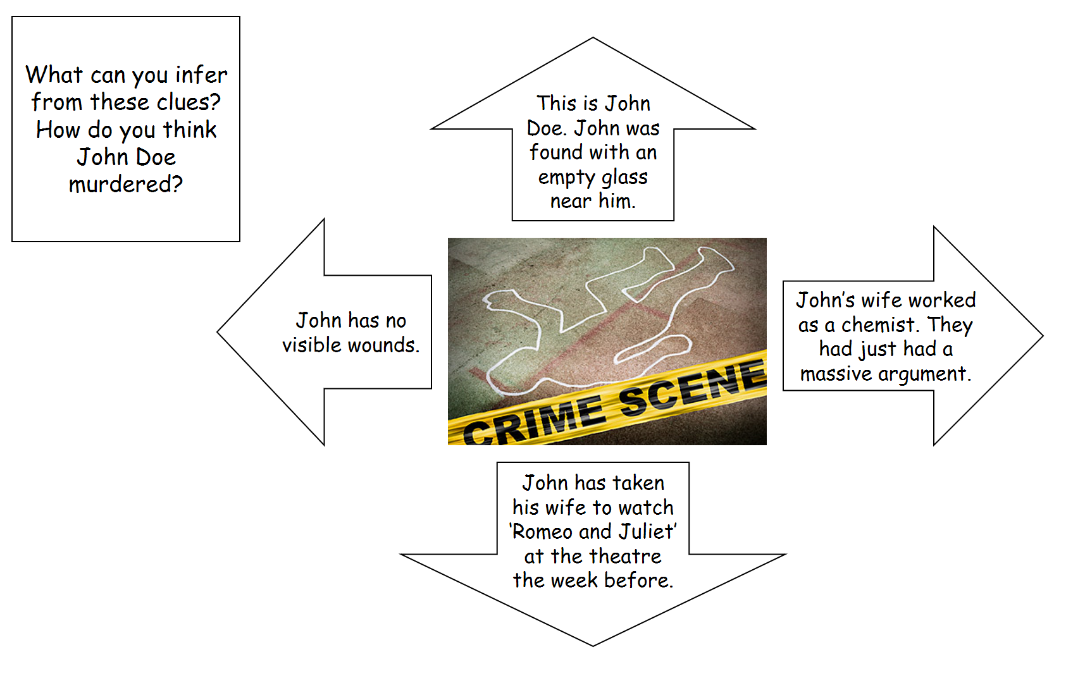
How was John murdered?
________________________________________________________________________________________________________

What clues tell us this?
____________________________________________________________________________________________________________________________________________________________
____________________________________________________

Red route:

You’ve discovered parts of a mysterious letter. Can you guess what it is about?

Why do you think it was written?
________________________________________________________________________________________________________

What can you infer (work out) from the tone of the writing?
________________________________________________________________________________________________________
________________________________________________________________________________________________________

Black route:

When we read a poem or a book we try to infer what it is about and what the writer’s thoughts are about what it is about.
Read this poem:

First Love
Falling in love was like falling down the stairs
Each stair had her name on it
And he went bouncing down each one like a tongue-tied
lunatic
One day of loving her was an ordinary year
He transformed her into what he wanted
And the scent from her
Was the best scent in the world
Fifteen he was fifteen
Each night he dreamed of her
Each day he telephoned her
Each day was unfamiliar
Scary even
And the fear of her going weighed on him like a stone
And when he could not see her for two nights running
It seemed a century had passed
And meeting her and staring at her face
He knew he would feel as he did forever
Hopelessly in love
Sick with it
And not even knowing her second name yet
It was the first time
The best time
A time that would last forever
Because it was new
Because he was ignorant it could ever end
It was endless

Brian Patten

What is this poem about?
________________________________________________________________________________________________________

What is the poet’s thoughts and attitudes towards what it is about? It is positive or negative? Can you find quotes from the text to support your ideas?
________________________________________________________________________________________________________
________________________________________________________________________________________________________
________________________________________________________________________________________________________
________________________________________________________________________________________________________

Can you spot any literary devices used (e.g. metaphor, simile, repetition)? Write down the literary device you find and the quote it came from.
________________________________________________________________________________________________________
________________________________________________________________________________________________________
________________________________________________________________________________________________________
________________________________________________________________________________________________________

Reading Journal
Complete this record with what you have read over the holidays – this will help for your Year 7 record log next year that you’ll have.

Title of book and author | Date started and finished | Personal comment – What did you think of the book?

