Freewill & Determinism – Key Terms

Term / Word | Your Initial Understanding Of It | Dictionary Definition | Explanation (in your own words) | Implication Of The Term On Other Terms
Freewill

Determinism
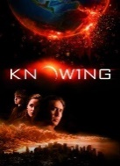
Pre-determinism

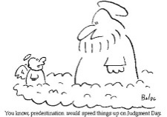
Predestination

Fatalism

Prediction

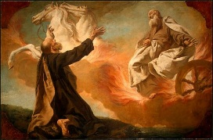
Prophecy

Premonition

Déjà vu

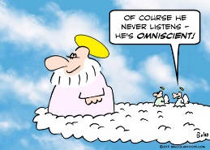
Omniscience

Free Will & Determinism – At The Movies

Band | Grade | Criteria | Key Questions / Tasks | Responses
7 | A* | Thorough knowledge and understanding. Effective use is made of well-chosen evidence and examples where appropriate. Different views are analysed and evaluated. The argument is strongly supported by reasoning and / or evidence, with an appropriate conclusion being drawn. | What is the film about?  How does the film present the concepts of FW&D? What is the film trying to suggest?  Has the film raised any particular philosophical issues about FW&D? And how well has the film done this?  Are there any key quotes / scenes particularly focused on the issues of FW&D?  Are the characters free or determined? Are we free or determined?  What factors might influence the characters decision-making?  To what extent can the characters (or us) override these influential factors and do something different?  Do you agree with the film in terms of what it is suggesting about FW&D?  Are there any alternative views on FW&D that could be argued against the concepts in the film? | ……………………………………………………………………………………………………………………..  ………………………………………………………………………………………………………………………  ……………………………………………………………………………………………………………………..  ………………………………………………………………………………………………………………………  ……………………………………………………………………………………………………………………..  ………………………………………………………………………………………………………………………  ……………………………………………………………………………………………………………………..  ………………………………………………………………………………………………………………………  ……………………………………………………………………………………………………………………..  ………………………………………………………………………………………………………………………  ……………………………………………………………………………………………………………………..  ………………………………………………………………………………………………………………………  ……………………………………………………………………………………………………………………..  ………………………………………………………………………………………………………………………  ……………………………………………………………………………………………………………………..  ………………………………………………………………………………………………………………………  ……………………………………………………………………………………………………………………..  ………………………………………………………………………………………………………………………  ………………………………………………………………………………………………………………………
6 | A | Key facts and ideas, presented with accuracy and relevance, along with evidence of clear understanding. Apt use is made of evidence and examples where appropriate. Different views are considered, with some critical analysis or comment. The argument is adequately supported by reasoning and / or evidence.
5 | B to C+ | Mainly accurate and largely relevant knowledge; demonstrates understanding of main ideas. Some use is made of evidence or examples where appropriate. More than one view is mentioned (though not necessarily in a balanced way), with limited analysis or comment. The argument is partially supported by reasoning and / or evidence.
4 | C to D- | Mainly accurate and largely relevant knowledge; basic or patchy understanding; little use made of relevant evidence and examples. Some grasp of the main issue(s) is shown; analysis or comment is limited. An attempt is made to construct an argument, partially supported by some reasoning and / or evidence. Little or no recognition of more than one point of view.
3 | D- to E- | Outline answer. Knowledge limited to basics, or low level of accuracy and/or relevance. Limited understanding. Evidence and examples lacking or barely relevant. Issue(s) only partly understood and appreciated. Some limited attempt made at analysis or comment. Reasoning is simplistic and basic. Evidence is minimal.
Free Will & Determinism – At The Movies: Extension Sheet

………………………………………………………………………………………………………………………………………………………………………………………………………………………………………………………………………………………………

………………………………………………………………………………………………………………………………………………………………………………………………………………………………………………………………………………………………

………………………………………………………………………………………………………………………………………………………………………………………………………………………………………………………………………………………………

………………………………………………………………………………………………………………………………………………………………………………………………………………………………………………………………………………………………

………………………………………………………………………………………………………………………………………………………………………………………………………………………………………………………………………………………………

………………………………………………………………………………………………………………………………………………………………………………………………………………………………………………………………………………………………

………………………………………………………………………………………………………………………………………………………………………………………………………………………………………………………………………………………………

………………………………………………………………………………………………………………………………………………………………………………………………………………………………………………………………………………………………

………………………………………………………………………………………………………………………………………………………………………………………………………………………………………………………………………………………………

………………………………………………………………………………………………………………………………………………………………………………………………………………………………………………………………………………………………

………………………………………………………………………………………………………………………………………………………………………………………………………………………………………………………………………………………………

………………………………………………………………………………………………………………………………………………………………………………………………………………………………………………………………………………………………

………………………………………………………………………………………………………………………………………………………………………………………………………………………………………………………………………………………………

………………………………………………………………………………………………………………………………………………………………………………………………………………………………………………………………………………………………

………………………………………………………………………………………………………………………………………………………………………………………………………………………………………………………………………………………………

………………………………………………………………………………………………………………………………………………………………………………………………………………………………………………………………………………………………

………………………………………………………………………………………………………………………………………………………………………………………………………………………………………………………………………………………………

………………………………………………………………………………………………………………………………………………………………………………………………………………………………………………………………………………………………

………………………………………………………………………………………………………………………………………………………………………………………………………………………………………………………………………………………………

