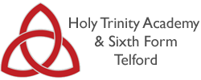
HOLY TRINITY ACADEMY
YEAR 11 INTO YEAR 12 SUMMER TRANSITION WORK 2018

Subject: | Qualification/Level: | Examination Board
English Language & Literature | A-Level | Edexcel
Is this a Linear or Modular A level? | - Linear (New from 2015)
- In a modular A level, AS examinations at the end of Year 12 are worth 50% of the A level.
- In a linear A level, any AS examination at the end of Year 12 will not count towards the A level.
The Summer Transition Tasks
- Read ‘The Great Gatsby’
- Complete the analysis of the article
How the work produced will fit into subsequent work and the specification as a whole.
During your course you are graded on 5 assessment objectives to pass you need to show ability to meet all of these.
AO1 | Apply concepts and methods from integrated linguistic and
 | literary study as appropriate, using associated terminology and coherent written expression
AO2 | Analyse ways in which meanings are shaped in texts
AO3 | Demonstrate understanding of the significance and influence of the contexts in which texts are produced and received
AO4 | Explore connections across texts, informed by linguistic and literary concepts and methods
AO5 | Demonstrate expertise and creativity in the use of English to communicate in different ways

How the work will be assessed and marked:-
In written and verbal work started as soon as you start the course in September.

Success criteria for this challenge:-
Students should return to school with a sound knowledge of the plot, characters and key themes/ideas of ‘The Great Gatsby’
Students should read the article and complete the tasks, to ensure they have considered purpose, voice, context and audience.
Resources to be used for this work.
- 1 x copy of ‘The Great Gatsby’ (£2 from Amazon Wordsworth Editions; New edition (5 May 1992) ISBN-10: 185326041X/ ISBN-13: 978-1853260414?
- See attached resources.
What equipment will be needed for the subject?
Own copies of coursework texts; a lever arch file and dividers for organisation of work; highlighters and coloured pens for annotations; lined paper. You will be issued with an exercise book in which significant work / essays will be completed and assessed to gauge your progress. You will be responsible for filing and organising your class notes.

Books to buy and books to read…..

- Component 2: Varieties in Language and Literature- ’The Great Gatsby’ by F. Scott Fitzgerald and ‘Othello’ by William Shakespeare.
- To ensure you are fully prepared for the start of the course in September, we would like you to purchase copies of both texts.
- We would also expect you to have read ’The Great Gatsby’ over the summer.
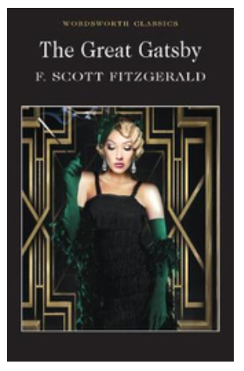
- We recommend you purchase this edition of ‘Othello’:
- Othello (Cambridge School Shakespeare): Written by Rex Gibson, 2014 Edition, (3rd Edition) Publisher: Cambridge University Press [Paperback] Paperback – 7 Feb 2014
- by Rex Gibson (Author) 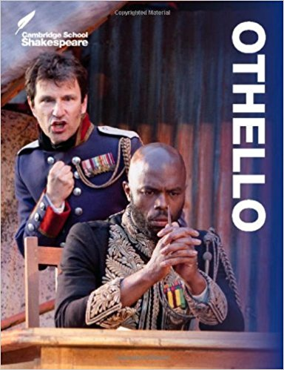
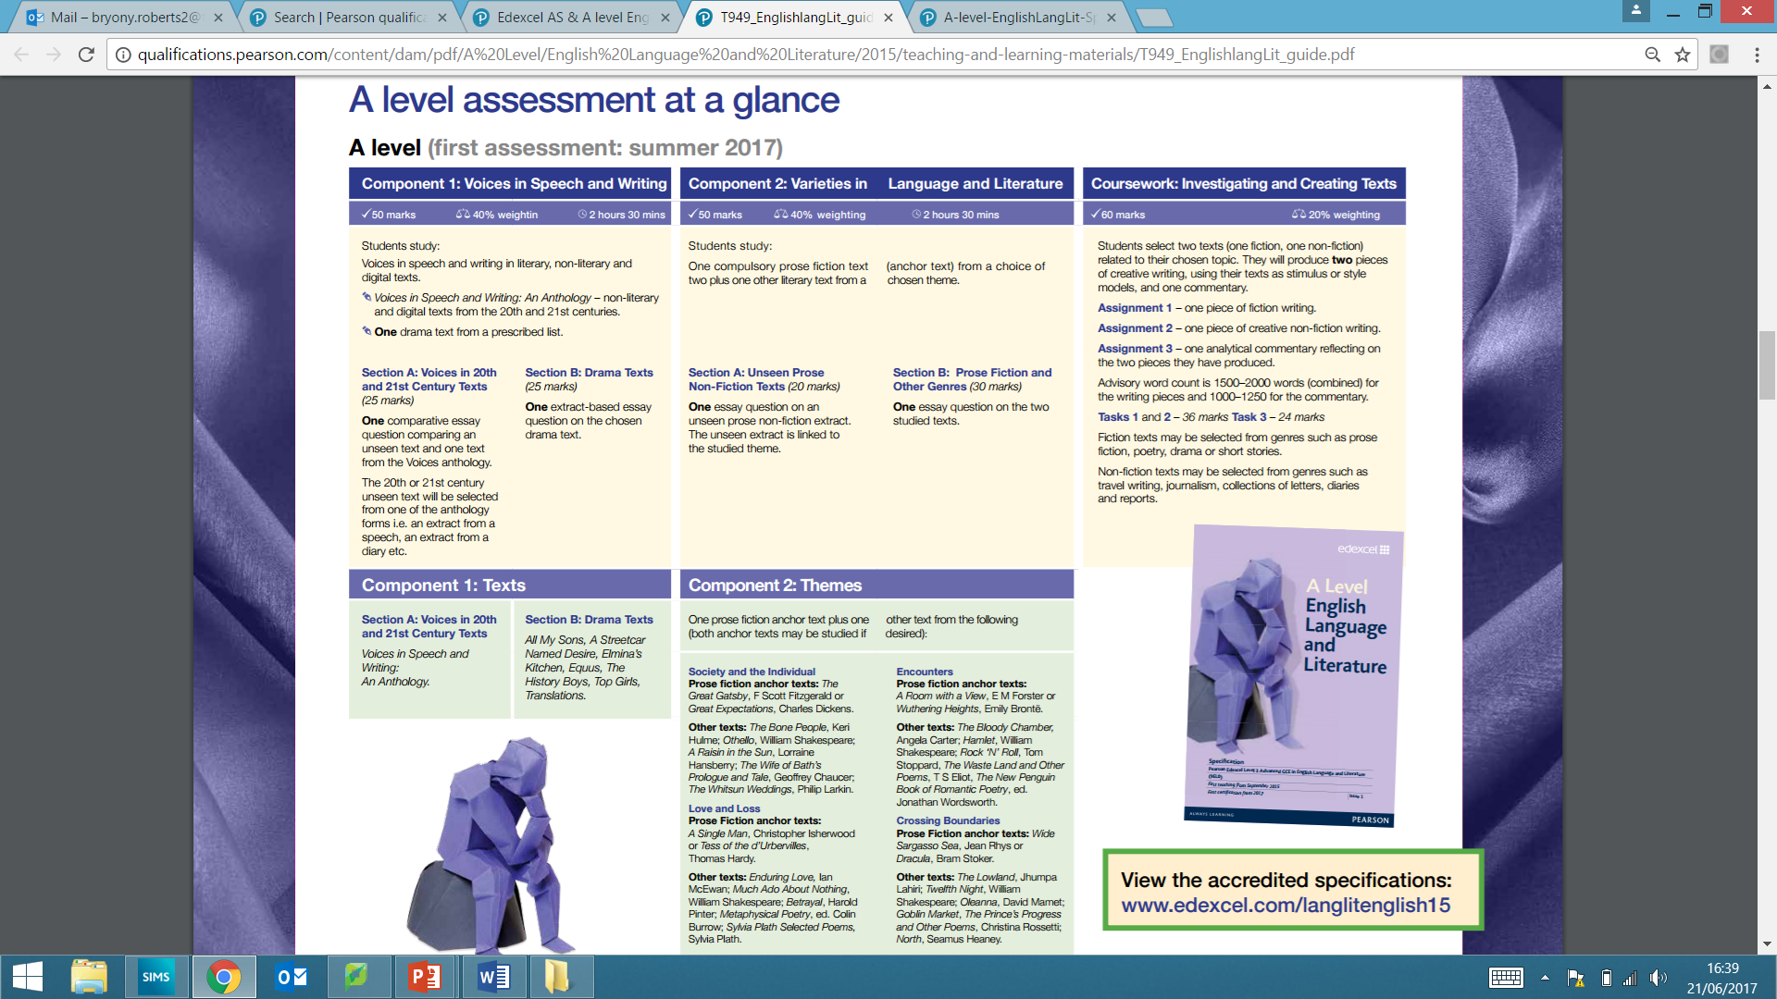

COMPONENT 1: Voice in Speech and Writing

‘As Gay people celebrate, the treatment of the disabled just gets worse’
This is an article from the i. newspaper by Ian Birrell, the former deputy editor of the Independent newspaper. He is a columnist, foreign correspondent, campaigner and co-founder of Africa Express.
Who is the audience of the article?
What is the purpose?

As gay people celebrate, the treatment of the disabled just gets worse

With more spending cuts looming, are we content to leave one minority locked out of society as second-class citizens?
- Ian Birrell
- @ianbirrell
- Monday 31 March 2014 01:10
- 34 comments
Click to follow
The Independent Voices
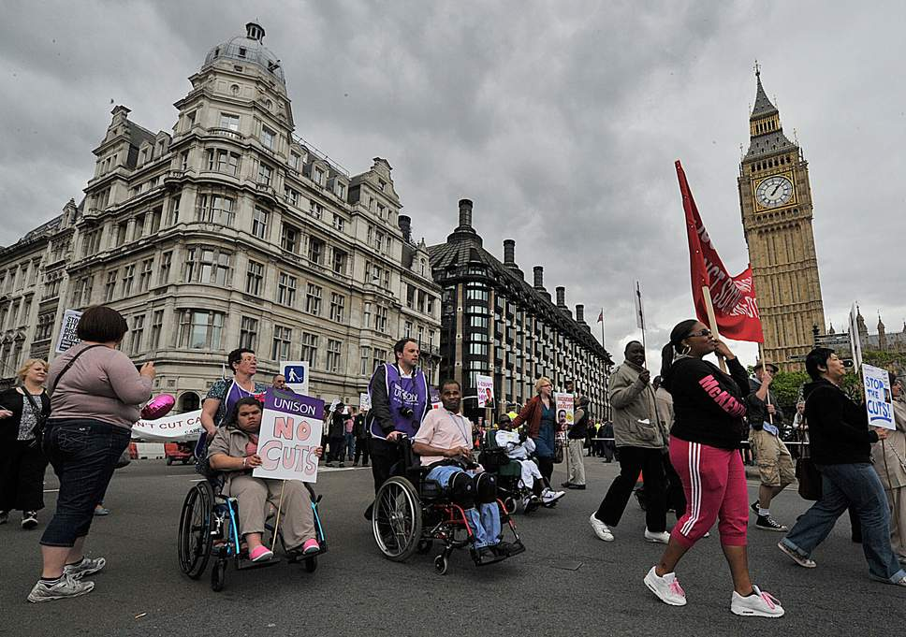
Protests in London over changes to disability benefits in 2013 ( Getty Images )
They were clearing up the confetti, nursing hangovers and disappearing on honeymoons yesterday after the first batch of gay marriages in Britain. It was a remarkable moment as the contented couples celebrated their unions with the traditional kiss. Within my lifetime, homosexuality has been first legalised, then embraced into everyday normality. Even bishops have begun to welcome the reform.
The ceremonies mark a milestone in the bumpy march towards tolerance and equality. We should rejoice at the speed with which people who were once jailed, mocked and used as a political football have taken their correct place at the heart of society. Politicians of all hues deserve praise for displaying courage in confronting the misanthropes who sought to stop lesbian and gay people from enjoying rights that the rest take for granted.
Problems remain with homophobic bullying in schools and bigotry abroad. But the reform shows how quickly attitudes can change. It is less than three decades since two-thirds of people thought any same-sex relationship was wrong; now, the same proportion support gay marriage – the numbers rising fastest among young respondents. There are 24 openly gay MPs (and more on Tory benches than those of other parties combined).
We have seen a similar rapid shift in attitudes on gender and race, for all the hurdles that still exist for both women and ethnic minorities. Yet, amid all the discussion of diversity and self-congratulatory talk of tolerance, one minority remains stuck in the shadows of society. Indeed, many members would argue that their life is getting worse, with hostility growing.
These are people with disabilities, a group growing fast in our ageing society. A new study by the charity Scope reflects the changing attitudes over the 20 years since it changed its name from the Spastics Society and shows the scale of the problem. In 1994, just over a third of disabled people said they experienced verbal abuse, with a similar number refused a service in a public place. Today, half of disabled people report discrimination in shops and almost a third when using leisure facilities.
It gets worse. Not only are people with disabilities far less likely to be in work despite being the most loyal employees, but almost two-thirds of those who develop a disability have lost their job within two years. Jean’s story is typical: after working for more than a decade, she was ignored by job agencies and had interview offers withdrawn when she started using a wheelchair. After finally getting an interview, it had to be held in a café because the work-place was inaccessible.
Reported hate crime is rising, with stories of awful abuse commonplace, while other studies have found that almost half of disabled people say attitudes against them are hardening. You can multiply all these damning statistics – the terrible stories of routine harassment – for people with learning difficulties. Just imagine the rightful outcry if this was happening to people because of their gender, sexuality or skin colour.

READ MORE
- FOR DISABLED PEOPLE, AND THOSE WITH LEARNING DISABILITIES, THE 'SACKING' OF ATOS WON'T CHANGE A THING
So why is this happening in the wake of the Paralympics, with all that optimistic talk of transforming attitudes? After all, there is anecdotal evidence that the event helped spark more sympathetic attitudes, while some businesses woke up to a market numbering millions of people. Yet Jean has been pulled from her wheelchair, sees buses refuse to stop for her and has even been accused of pretending to be disabled.
One reason is the lack of social and workplace interaction, such a crucial motor in changing attitudes. So instead of invitations to drinks after work and weekend dinner parties, there is befuddled British embarrassment at best, coldness at worst, towards people with disabilities. As a consequence comes a failure to understand their hopes, fears and desires.
Then there is the lack of political power – one more legacy of the poverty and woeful support endured by many disabled people. Digital technology has helped, but the idea of seeking a seat in Parliament is a joke for people who struggle to obtain a seat on the bus. At the last general election, more than two-thirds of polling stations had significant barriers to accessibility.
It also comes down to money. It is expensive to be disabled: on average, it costs £550 extra per month. It is costly to convert buildings, build specialist centres and ensure support for disabled children to get a decent education. As with gay rights, both main parties have passed landmark legislation but, more recently, both undermined their own steps forward. Disabled people have been victims of scrounger rhetoric and botched cuts, whether foolish measures such as the bedroom tax or badly implemented attempts to ensure that the right people claim benefits.
It is great to see Britain become more tolerant. But, with more spending cuts looming, are we content to leave one minority locked out of society as second-class citizens? Just as with gay and lesbian people, disabled people want only the same rights as everyone else. And remember that only one in six people with disabilities was born with them; one day this minority might include you, whatever your colour, gender or sexuality.

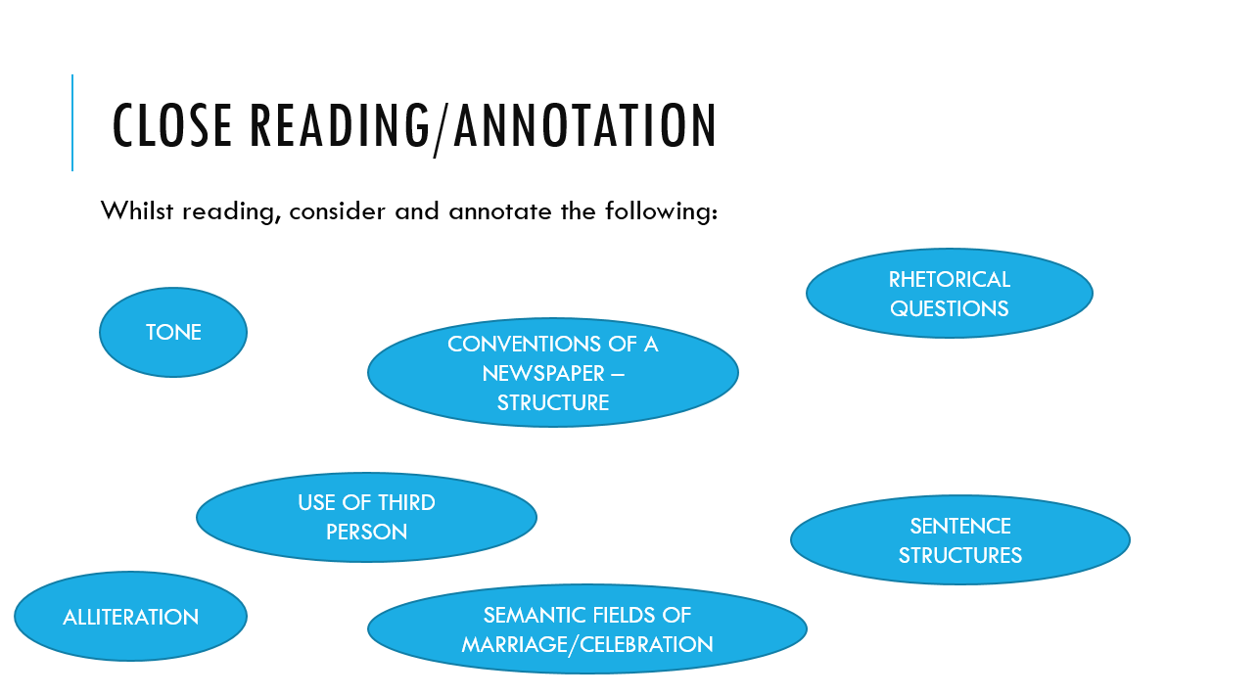

Who is the audience of the article?
What is the purpose?
What is the ‘voice’ of the writer?
What does the article show us about society’s attitudes?

TASKS:

1. How is the overall tone of the article achieved? Is the article positive towards society’s attitudes in general? How can you tell?
What does the writer intend to tell us about themselves? Do they create a sense of their personality in the text, or is it removed or distant?

2. Re-write the article from the voice of someone who has recently become disabled as a diary or memoir.
[Focus on the second half of the article]

